Heze University Holds the 2018 Freshmen Opening Ceremony and the Military Training Summary Commendation Conference
2018-09-12 16:54
September 12, Dangui fragrance . Our school 2018 freshmen opening ceremony and military training summary recognition Congress held in the school's new track and field grand. School leaders Wang Huanliang, Jiang Tongsong, Meng Linmei, Huang Jimin, Liu Xingtan, Zhou Guangyan, Hu Zundong, Ma Ming, Director of Heze military Subregional War Preparedness Construction Office, and Zhou Shenghua, deputy chief of staff of Heze detachment of the Shandong Armed Police Corps, The deputy captain of Heze detachment of Shandong Provincial Armed Police Force and Guo Liangyu, head of the freshman military training regiment of Heze College, attended the meeting. Huang Jimin, member of the Party Committee and Vice Premier, presided over the meeting.
At 9 am, the Congress officially opened in the solemn national anthem. Li Shuangjiang, a military training regiment, directed the new military training regiment to perform a presentation on military subjects. Class 2018 freshmen in the performance with a neat square, full of spirit, loud slogans followed by the rostrum, to review. They valiant, moving sonorous, with a powerful military posture to show the school's vigorous, uplifting spirit, for the first lesson of the school to hand in a qualified answer.
The main responsible persons of each unit, the deputy secretary of the Party committee of the second level school, the director of the school work office, the counsellor, the class teacher and all the freshmen of the 2018 class attend the meeting.
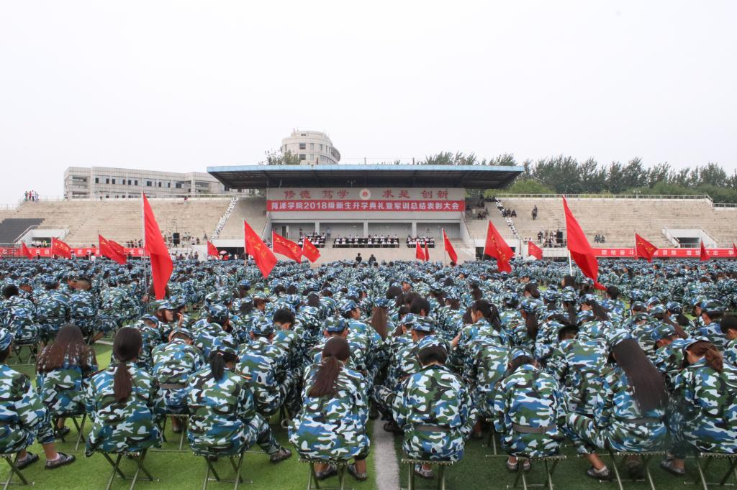
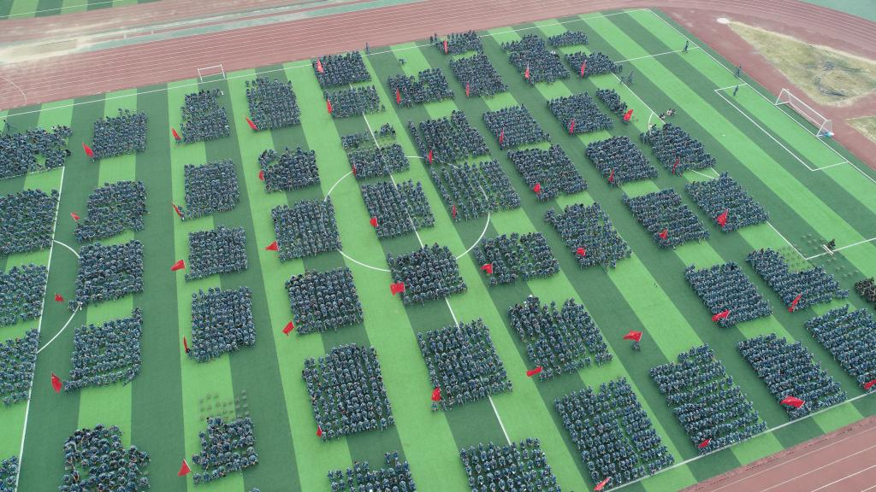
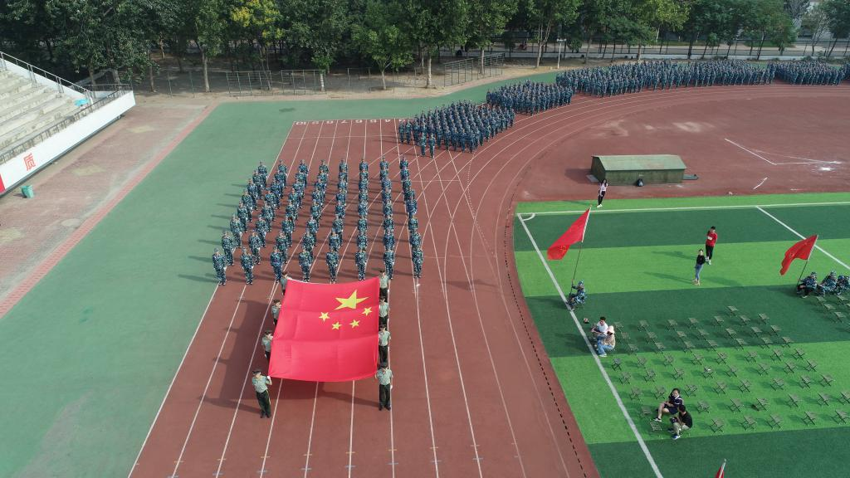
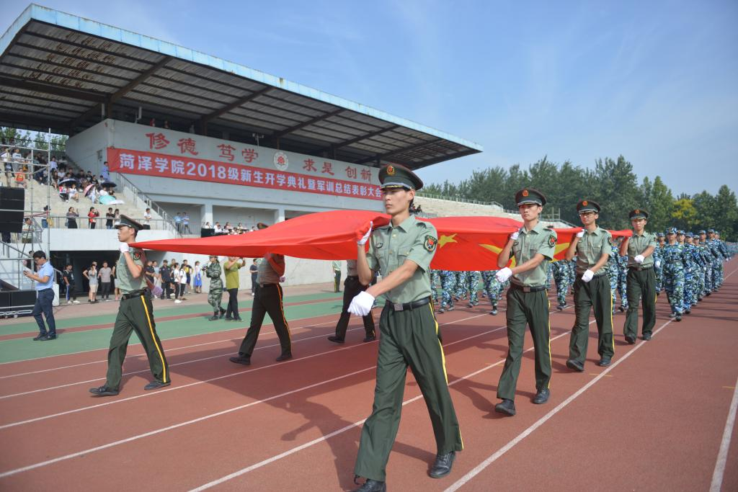

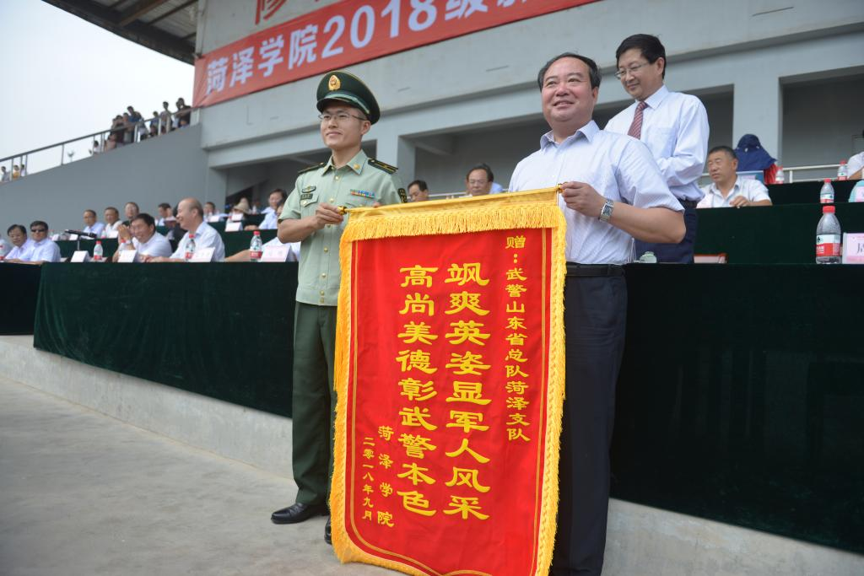
Wang Huanliang, party secretary and leader of the military training leading group, presented the banner to Heze detachment of Shandong Provincial Armed Police Force on behalf of the school.
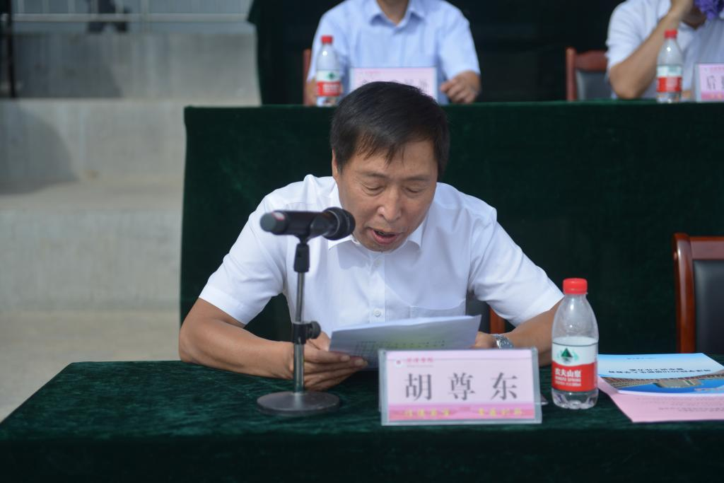
Hu Zundong, member of the party committee and vice premier, read out the decision on the recognition of advanced collectives and advanced individuals for the work of new students in military training at the level of 2018, and the heads of troops and school leaders successively awarded awards for the advanced collectives and advanced individuals who had been commended.

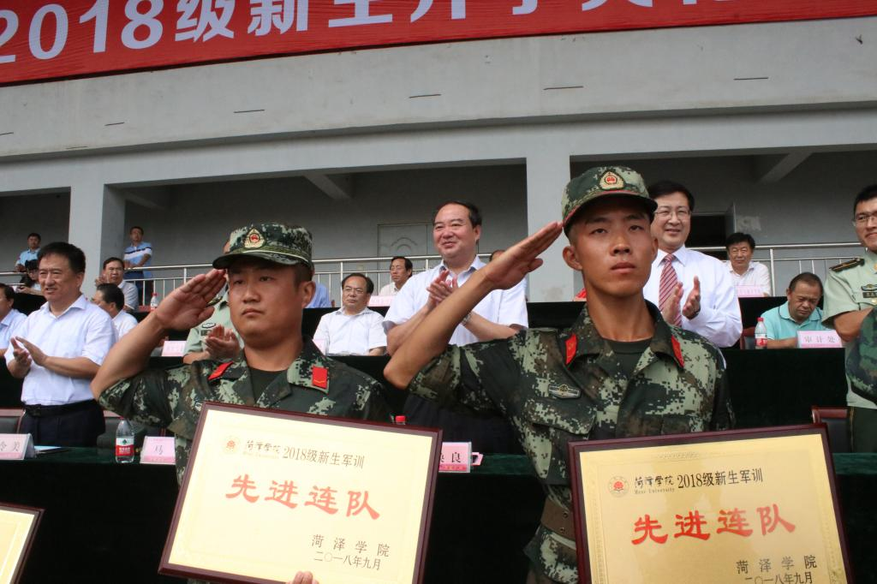

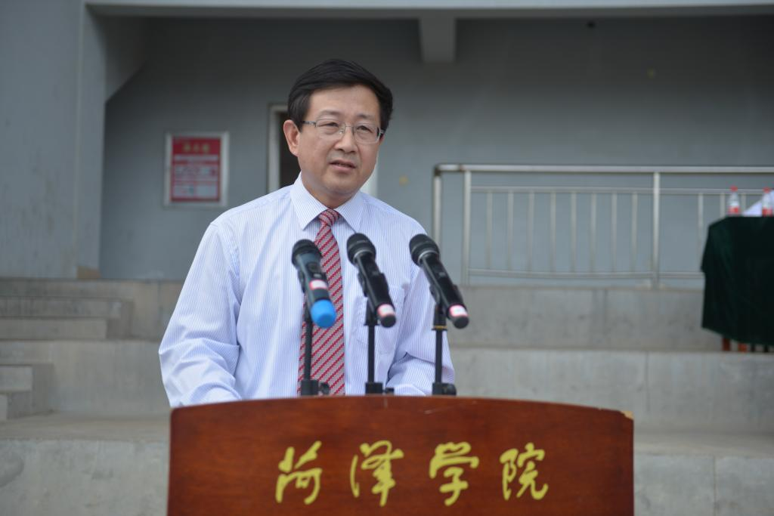
Deputy secretary of the school party committee, president, leader of the military training work, doctoral supervisor Professor Jiang Tongsong made a speech welcoming the new year.
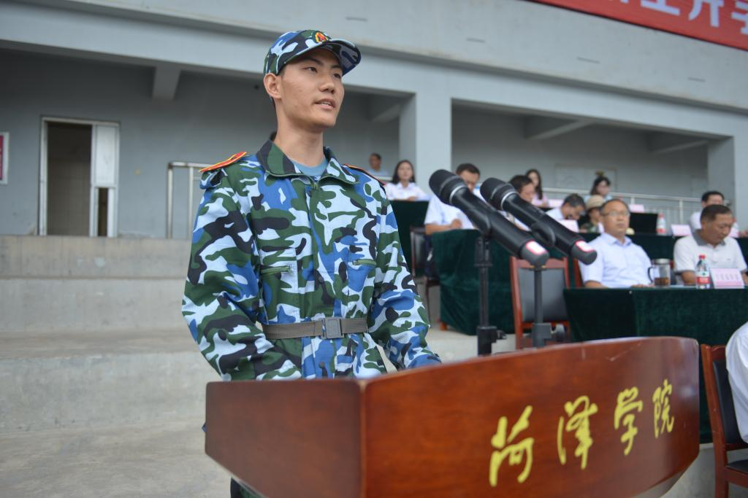
Speaking by Zhang Kai, freshman of Class 2018, School of Pharmacy
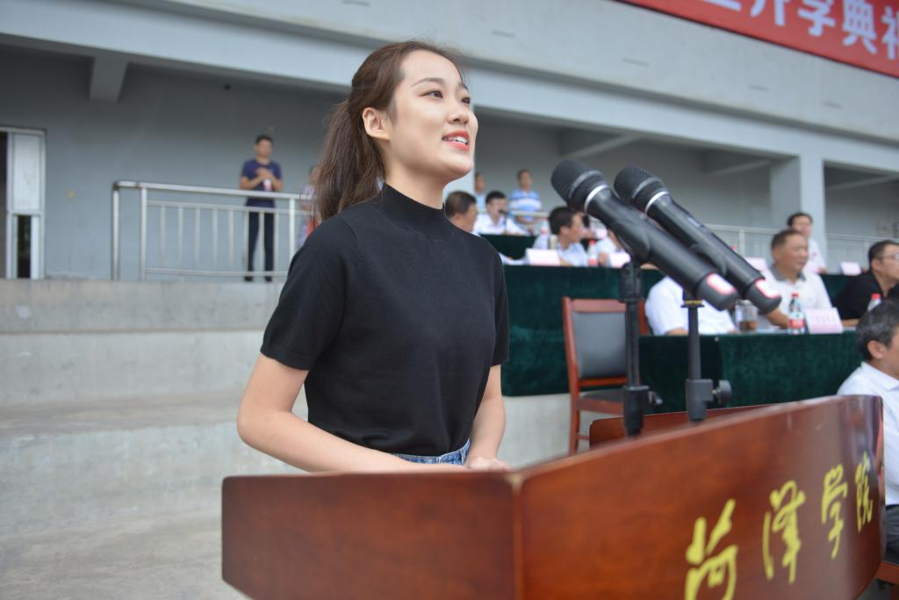
Old student representative, teacher education college, Gu Wen

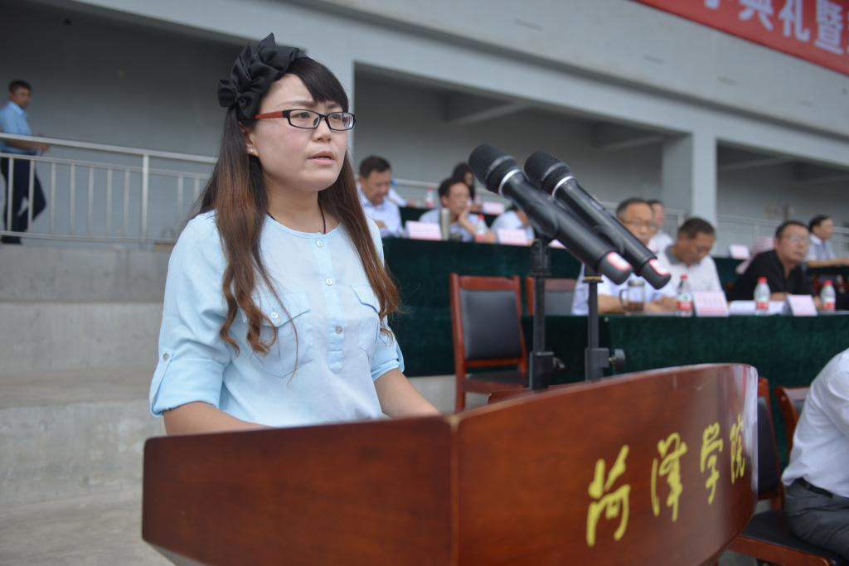
Alumni representative, graduate of the class of chemical and chemical engineering, Dr Amy choi, class of 2005。

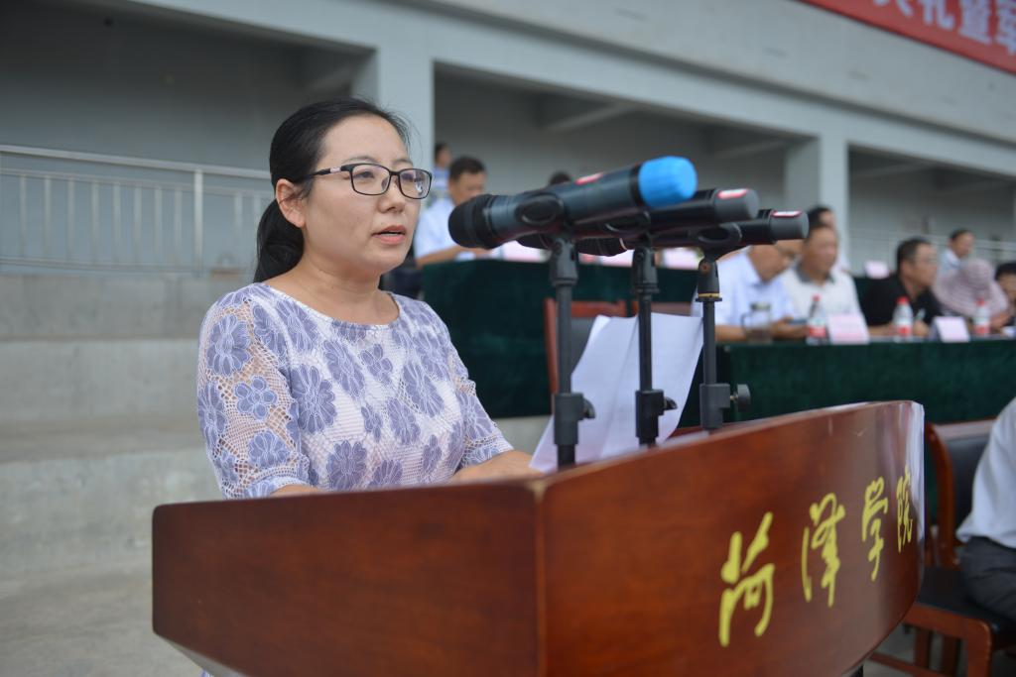
Speech by Dr. Wang Juan, Deputy Dean, Faculty of Agriculture and Bioengineering, teacher's Representative

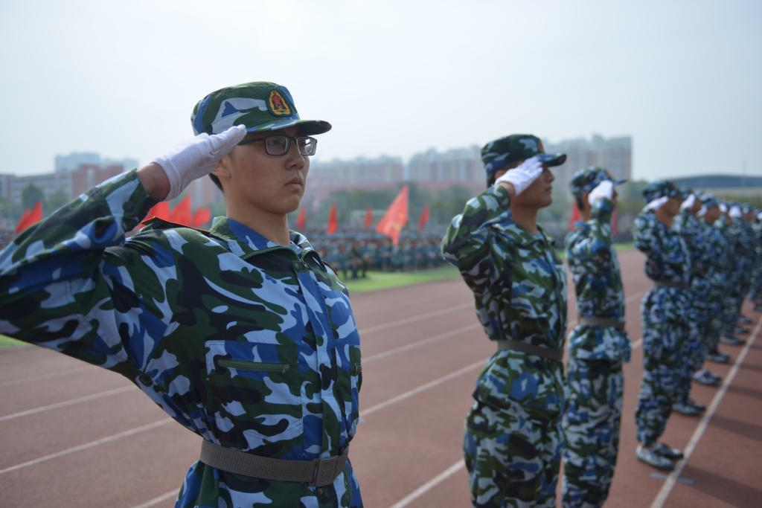
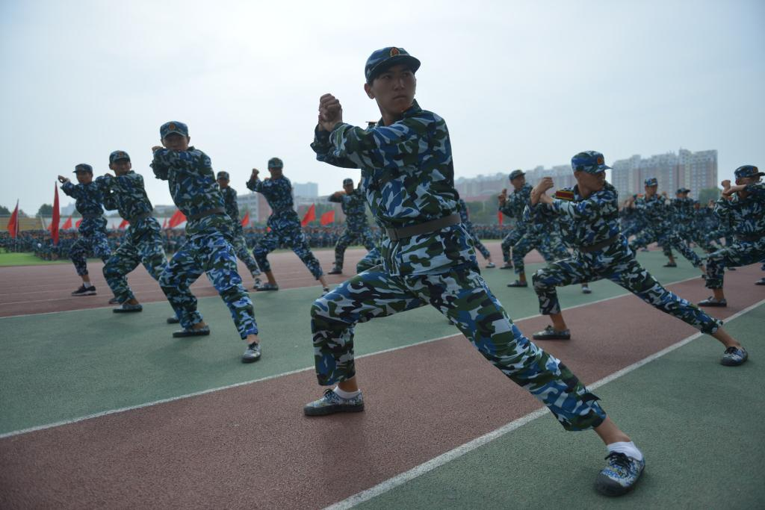
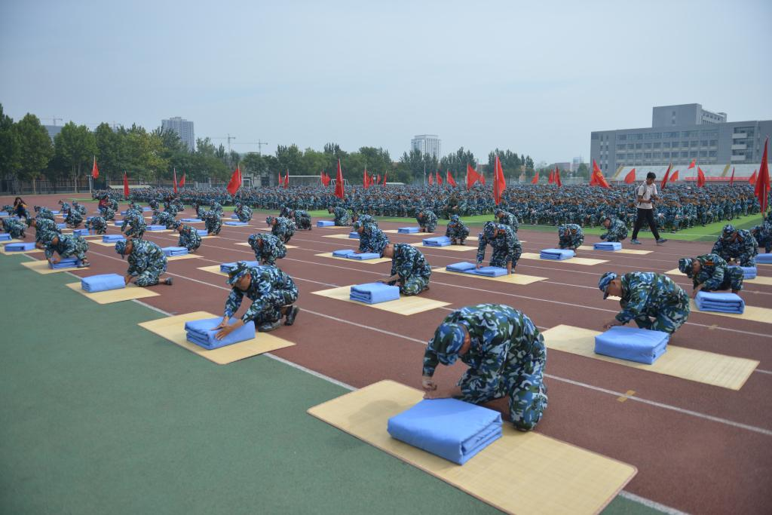
编辑：Lvjie Interpreter:Hou Sanlin

